Step1 – Created a new Job – named as Job 3

Step2- attached the dedicated Jenkins agent named slave1 because we only want to install docker on puppet-agent not on puppet server.

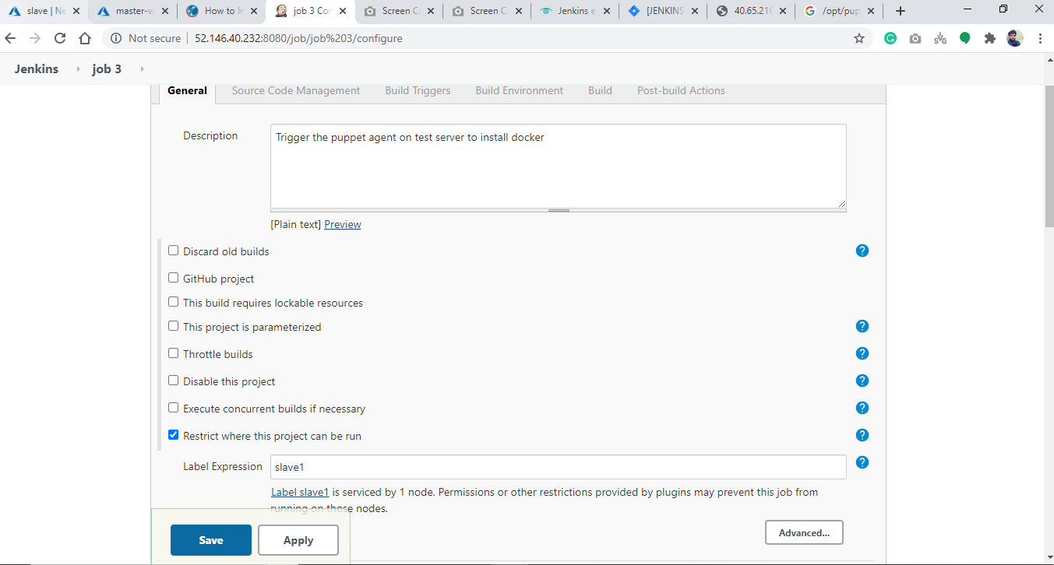

Step3- added a build trigger which pull the configuration in every 15 min from puppet server.

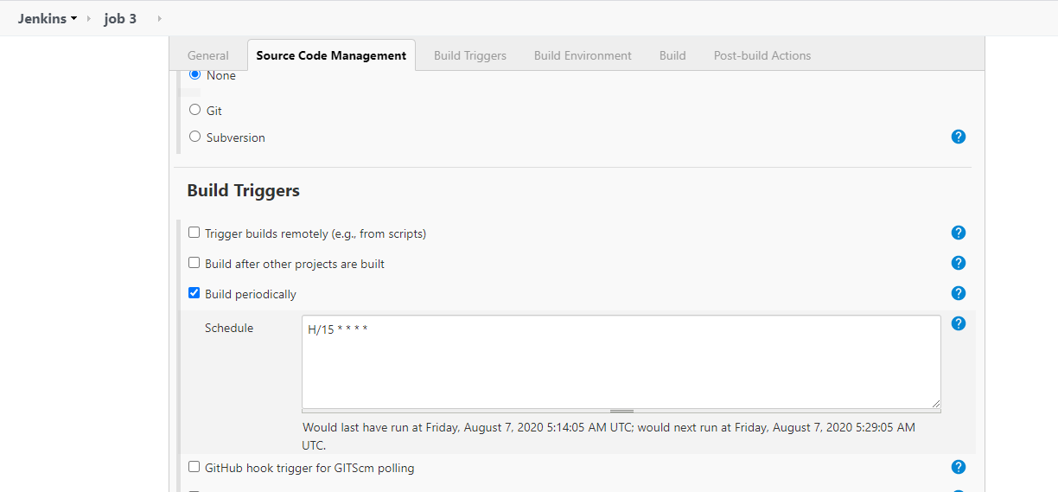

Step4- In Build Section – written the command to fetch the configuration from puppet server –

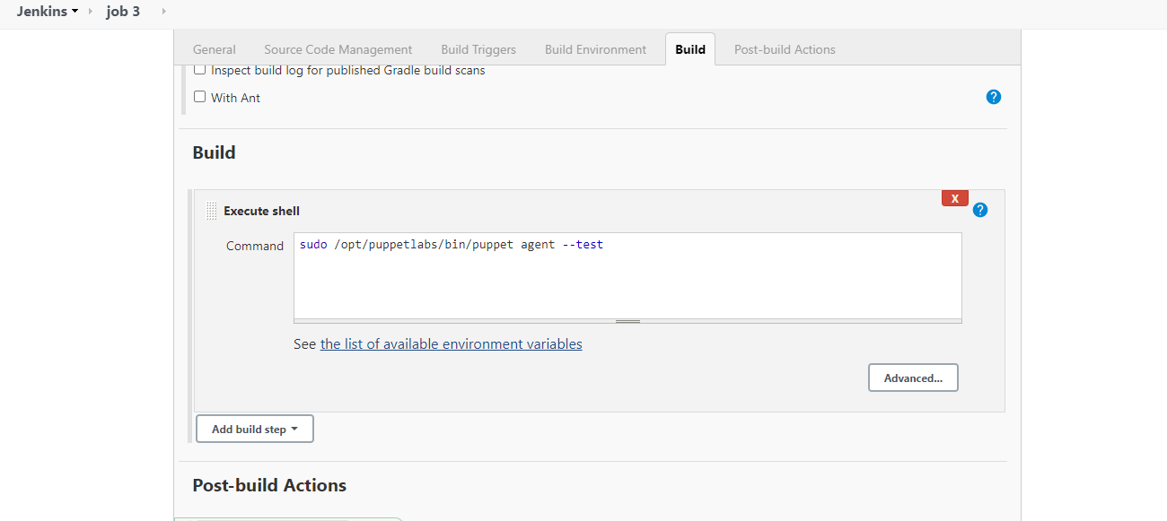

Log - 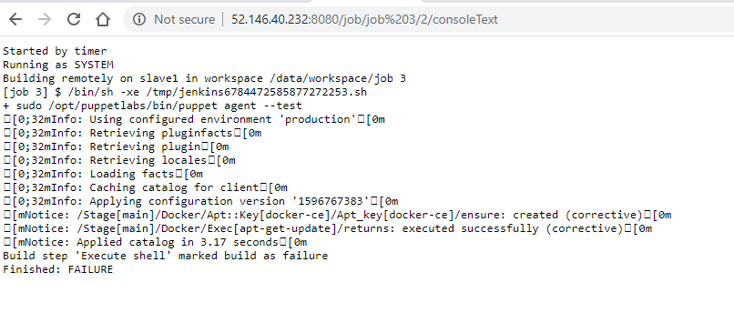

Docker is installed on puppet-agent but it Jenkins log shows failure. Actually it happens and on project description it is also mentioned.

**NOTE: Jenkins may show Job 3 as Failed, even though Console Output is successful. Enable the next job to run even if this job fails, as a workaround**

**Puppet Server Configuration – did manually**

Step1- Created a file “docker.pp” on location

/etc/puppetlabs/code/environments/production/manifests

By default, it takes production environment

Step2- docker installation code –

node 'client'{

class{'docker':}

}

class docker {

include apt

$prerequisites = ['apt-transport-https', 'ca-certificates']

package { $prerequisites: ensure => installed} ->

apt::key { 'docker-ce':

ensure => present,

id => '9DC858229FC7DD38854AE2D88D81803C0EBFCD88',

options => 'https://download.docker.com/linux/ubuntu/gpg',

} ->

apt::source {'docker-ce':

location => 'https://download.docker.com/linux/ubuntu',

release => 'xenial'

} ->

exec { 'apt-get-update':

command => '/usr/bin/apt-get update'

} ->

package {'docker-ce': ensure => installed}

}